|  |
| --- |
|  |
| Borough of Bloomsbury, County of Hunterdon  Newsletter  Page 1 Tel: 908-479-4200  Fall/Winter 2025 Edition bloomsburyborough.com |
|  |

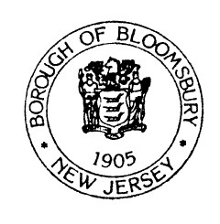

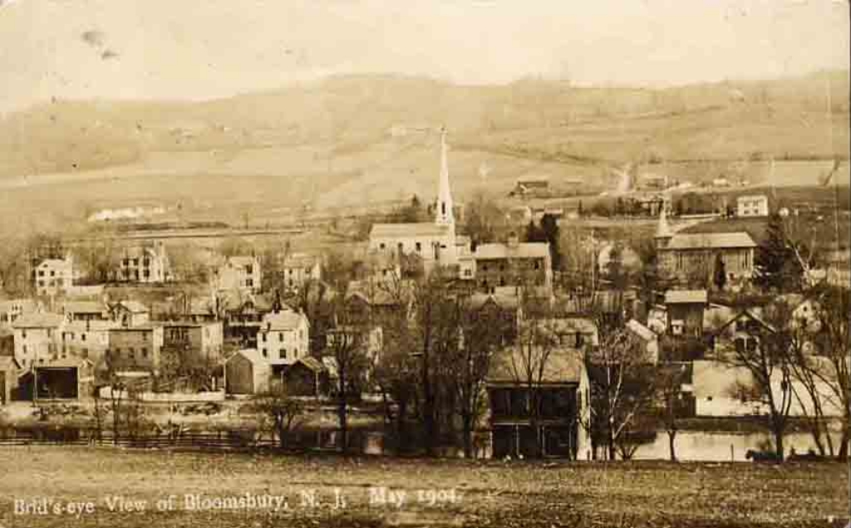

# DATES TO REMEMBER

## October 11

## Clean Up Day 8 to 11 am

## October 10

## Leaf Pick Up Begins

## November 24

Leaf Pick Up Ends

## October 31

Trick or Treat 6 to 8 pm

## December 26

Christmas Tree Pick Up Begins

## January 12

Christmas Tree Pick Up Ends

2026 PET LICENSING REMINDER

All Dogs and Cats **MUST** be licensed by **January 31, 2026** to avoid late fees.

Applications can be mailed to

91 Brunswick Avenue, Bloomsbury, NJ 08804.

Additional applications can be obtained at Borough Hall during normal business hours

or online at [**www.bloomsburynewjersey.com**](http://www.bloomsburynewjersey.com)

Borough of Bloomsbury

FALL BRUSH PICK UP

Fall Brush was held 9/12 – 9/22

For residents who live on Main Street in the area of the

Main Street – Phase V construction area, please email the Borough Clerk to advise if you will require brush pick-up by 10/10/2025.

[clerk@bloomsburyborough.com](mailto:clerk@bloomsburyborough.com). Brush is to be no longer than 5’ in length, butt end to the curb, 3” in diameter or less.

LEAF PICK UP

10/10 – 11/24

Leaves will be picked up curbside this fall. The Department of Public Works will not take leaves from your driveway, sidewalk, yard or any other part of your property.

**LEAVES ONLY** – leaf piles with sticks, twigs, grass clippings or any other debris will not be collected.

\*\*\***NOTE** – Landlords – It is your responsibility to notify your tenants about brush and leaf pick up.***

**Borough Hall has Moved (See page 3)**

**CLEAN UP DAY**

**For Properties within the Borough of Bloomsbury ONLY**

**SATURDAY – October 11, 2025 - 8:00AM – 11:00AM**

Each property owner will be permitted to take the equivalent of TWO pick-up truck loads of “junk” to the Borough Park to be collected and placed into the dumpsters by BOROUGH

EMPLOYEES.

If you are a landlord, *you are responsible* to see that your renters are cared for.

Any Senior Citizens or Handicapped property owners unable to deliver their “junk” to the park may call the Borough Hall at 479-4200 for assistance.

Long items must be reduced to manageable 4-5 foot lengths.

**\*\*\*NO ONE WILL BE PERMITTED TO DUMP WITHOUT PROVIDING PROOF OF RESIDENCY.**

**We will not take:**

Household Garbage Chemicals Car Parts

Hazardous Waste Concrete Blocks Paints

Tree Stumps Building Materials Brush

Air Conditioners Refrigerators Tires

Freezers Appliances with Freon TV’s

Computers Monitors Electronics

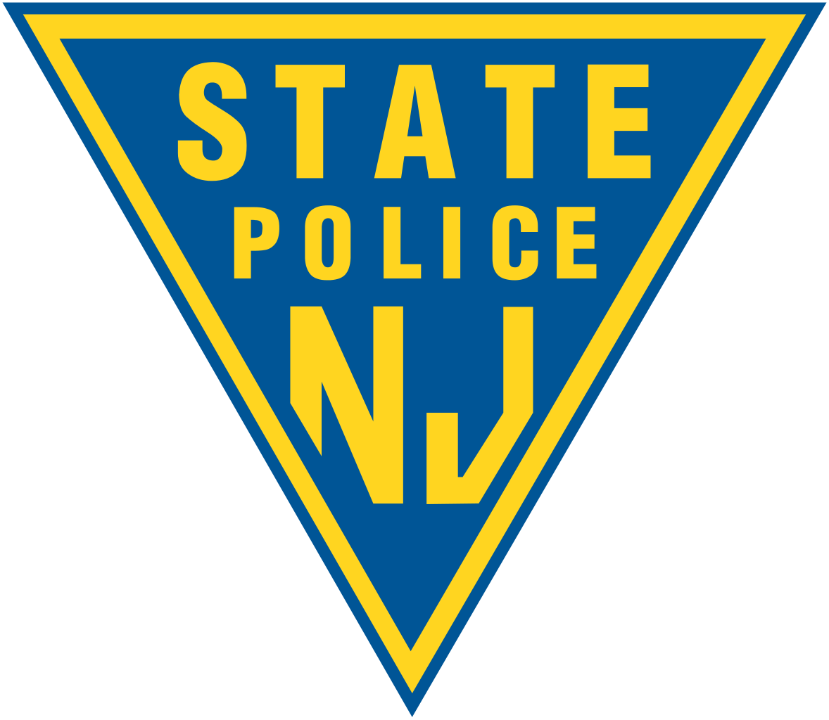

|  |
| --- |
|  |
| The State Police remind residents to report any illegal or suspicious activity including trespassing, dirt bikes, or ATV’s riding on Borough Streets or in the Borough Park immediately by calling the Perryville Barracks at 908-730-7042. _______________________________ **BOROUGH PARK RULES**  ■ Park CLOSED from Dusk to Dawn.  ■ No Alcoholic Beverages.  ■ No Glass Containers.  ■ No Dumping.  ■ No ATV vehicles.  ■ Pets must be leashed at all times.  ■ Owners must clean up pet waste.  Anyone observing any violation should contact the State Police by dialing 908-730-7042 immediately.  **Violators will be prosecuted.**  ___________________________  **Property Maintenance Reminder:**  Residents must keep mailboxes behind the curb line, and trees, shrubs and plants trimmed back from the public right of way to allow for unobstructed vision and passage of pedestrians and vehicles. |

**Borough Hall has been relocated to:**

The American Legion Building - 323 Greenwich St., Stewartsville, NJ 08886

Zoning/Code Enforcement Officer & Tax Collector Hours – Mondays 5 – 7 PM

Tax payments and general correspondence can continue to be mailed to:

91 Brunswick Avenue, Bloomsbury, or placed in the white drop box at the old Borough Hall. Taxes can also be paid on-line at bloomsburyborough.com.

**Council Meetings are held in person at the American Legion 4th Tuesday of each month, and Planning board meetings are continuing to be held via Zoom. See link at bloomsburyborough.com.**

**UPDATES FROM THE MAYOR**

Main Street Phase V work has begun and will include curbs, sidewalks, drainage and resurfacing the last stretch of Main Street. Please expect partial lane closures and some traffic disruption as they complete the project which will be a long awaited, great improvement to the entrance to town, and fix drainage issues.

Councilman McClymont and I had the pleasure of attending a meeting with County Commissioners on September 16th held in Clinton Township where they announced the Borough would be awarded the maximum $10,000 Local Law Enforcement Grant Award, which we will utilize for traffic calming signage including installation of a four-way stop at Main and Center Streets and purchase of a digital speed monitoring sign. Thank you to our Clerk/Administrator Lisa Burd for completion of the grant application.

We applied for the 2025 Municipal Park & Recreation Grant Program and if awarded will make improvements to Tuxhorn Park parking area including removal of the old timber fence posts, installation of a new fence and gates, and regrading & re-stoning of the parking area. You may have noticed the Borough was able to replace the playground equipment with an award from the same grant last year. More progress!

Last, thank you to Matt & Henry of our Public Works Department for their hard work to keep our parks beautiful and for going above and beyond in replacing the snack shack roof with metal roofing and installing new facia – Excellent Job! – Mayor Papics

Trick or Treat 2025

Friday, OCTOBER 31, 2025 - 6:00 – 8:00 PM

**Tips to Stay Safe:**

* Always have adult supervision.
* Remain visible and remember to obey all traffic laws.
* Only visit houses with lights on.
* Always have an adult check your treats before you eat.
* Decide which homes you’ll visit before you go out.
* Have a great time!

Snow Parking Reminder

All motor vehicles must be removed from the streets in the Borough when more than 2" of frozen precipitation falls and must remain off the street until 12 hours after the cessation of frozen precipitation events.

Residents and visitors needing additional off-street parking during inclement weather can park at the Borough Park located at 100 Church Street, or at 98 North Street in the lot located at the corner of Gardner Street and North Street.

Parking is at your own risk and please be sure to remove vehicles from the lots as soon as the streets are completely clear. If you have any questions or concerns, please call Borough Hall at 908-479-4200.

Beginning November 15th and ending March 31st, there shall be NO PARKING on the south side of Brunswick Avenue from its intersection with Church Street (Route 579) to its intersection with Route 173 during and following any period of frozen precipitation (e.g., snow, sleet, etc.) for so long as the roadway is not entirely free of accumulations of frozen precipitation.

Winter Snow Removal

After Council’s review of the Borough’s snow removal practices, a decision was made that non-essential alleys that are difficult to navigate either by reason of their configuration or man-made obstructions will be cleared when manpower and conditions permit. As a result, if plow drivers of the Borough’s DPW determine in their sole discretion that accessing or attempting to plow any of these alleyways is dangerous and could result in either damage to a borough vehicle or to an adjoining residence, snow will not be removed from those alleys until conditions permit safe passage for DPW vehicles.This is in accordance with New Jersey Statutory Regulations which only require removal of snow and/or ice from main thoroughfares within the Borough.

The Bloomsbury Hose Company requests your assistance and ask that you clear snow from around any hydrant adjacent to your property.