|  |
| --- |
|  |
| Borough of Bloomsbury, County of Hunterdon  Newsletter  Page 1 91 Brunswick Avenue  Spring 2024 Edition bloomsburyborough.com |
|  |

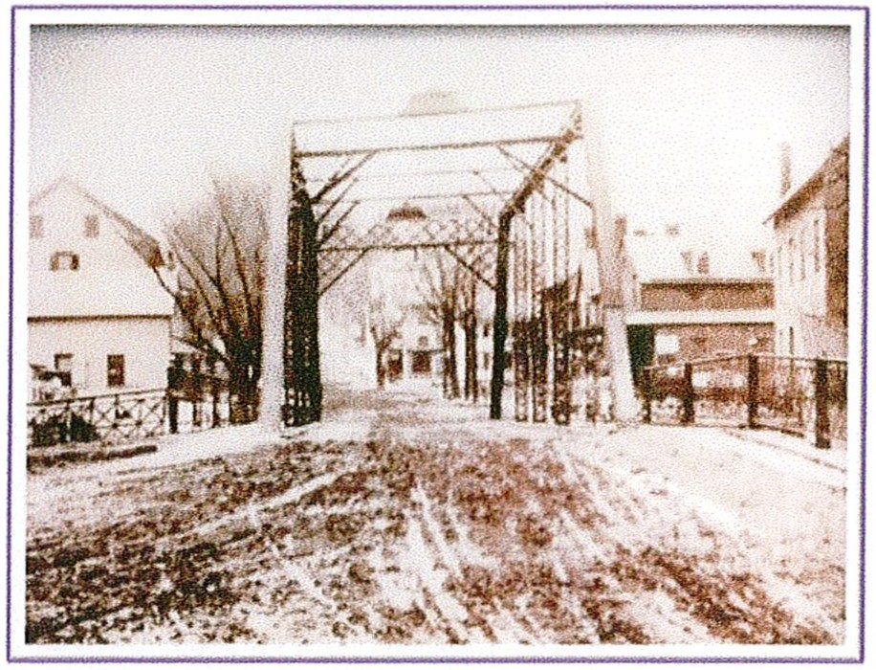

# DATES TO REMEMBER

## April 5

Spring Brush Pick-Up Begins

## April 15

Brush Pick-Up Ends

## March 30

Egg Hunt at The Park

## June 8

Town for Sale

## September 1

Fall Newsletter

## October 12

Clean Up Day 8-11am

## September 13

Fall Brush Clean Up Begins

## September 23

Fall Brush Clean Up Ends

|  |
| --- |
|  |
| Spring Brush Pick Up 2024  Brush is to be no longer than 5’ in length,  Placed butt end to the curb,  3” in diameter or less. Brush placed out after Monday, April 15th will not be collected. |
|  |



**FREE ELECTRONICS RECYCLING 2024**

**When:** March 16th, June 22nd, October 5th, and November 16th  
**Hours:** 9:00am to 1:00pm **RAIN OR SHINE**  
**Where:** Route 12 County Complex, Flemington, NJ

**Contact:** (908) 788-1351

**Sponsored By:** County of Hunterdon and Newtech Recycling Inc. 732-564-3110

**Acceptable Electronics for Disposal**

**We will accept:  (Items listed are not intended to be all inclusive. Call for other items.)**

**Desktop Printers, Desktop Fax Machines, Computers, Computer Monitors, Televisions, DVD Players, Radios, Cell Phones, Digital Cameras, Keyboards**

**For larger quantities or commercial disposal of computers contact Newtech Recycling Inc. at 732-564-3110**

**Special Events in Hunterdon County**

These events only happen once a year; don’t miss the opportunity to join us.

**Maple Sugaring Living History Open House**

Saturday, March 9, 9:00 AM to 3:30 PM

Echo Hill Park, 42 Lilac Dr, Flemington, NJ 08822

FREE-No pre-registration required.

All Ages, All children must be accompanied by an adult.

Experience first-hand the North American tradition of maple sugaring at Hunterdon County’s Maple Sugaring Program. You’ll take a trip through time to experience the art of the sugaring process. Along the way you will see an early American Frontiersman tapping his trees, visit a sugar “farmer” at his evaporator, and enjoy a Native American story about the discovery of maple sap. Sessions start every 30 minutes beginning at 9:00 AM. The last session starts at 2:30 PM.

**Earth Day Festival**

Saturday, April 20, 10:30 AM to 4:00 PM Echo Hill Park, 42 Lilac Dr, Flemington, NJ 08822

FREE-No pre-registration required.

All Ages, All children must be accompanied by an adult.

Join us for the Division of Parks and Recreation’s 20th Earth Day event! Help us celebrate the one, the only, Planet Earth! At 11:30 AM, learn about Lenape Lifeways with Carla Messinger, a Lenape descendant from Pennsylvania, from the Turtle Clan Lenape. At 1:00 PM, enjoy a live animal show with Rizzo’s Wildlife World. All day, meet animals and do other activities with local 4-H clubs. Make and take home a recycled or natural craft. Visit the tables of local environmental organizations to find out what they do. See what critters live in the stream (bring water shoes or boots), and try out fishing on the pond. Enjoy an Earth Day StoryWalk®! The event will conclude with a campfire and an interactive story at 3:00 PM. Bring your own campfire snack if you would like.

**Spring Break Nature Day**

Wednesday, April 3, 9:00 AM to 3:30 PM

Echo Hill Park, 42 Lilac Dr, Flemington, NJ 08822

Cost: $38 per child - Pre-registration required Session A: Grades K-2 Drop-off program Session B: Grades 3-5 Drop-off program Instructors: Debra Reed, Laura Bush, Tom Sheppard, and Liz Fulmer Join park staff for a day of nature fun over spring break! We will enjoy activities such as an insect study, stream study, and shelter building. Please bring a lunch and a refillable water bottle. Please wear sturdy close-toed shoes and dress for the weather. Bring closed-toed water shoes for the stream and other shoes/pants to change into afterward.

BLOOMSBURY RECREATION COMMITTEE  
IS PROUD TO SPONSOR THE 2024



When: Saturday, March 30, 2024 - 10:00 am

Rain/Snow Date: Saturday, April 6, 2024 - 10:00 am

Where: Mayor Tuxhorn Park

Open to all Borough residents and Bloomsbury School Children Ages 1 through12 years old

*Please bring a basket for collection*

*Multiple prizes per age group!*

*Questions? Please Contact Sarah Sleg or Megan Henry@908-878-6569*



## 

**HUNTERDON COUNTY HEALTH DEPARTMENT HOUSEHOLD HAZARDOUS WASTE CLEANUP DAY**

**WHEN: March 23, 2024, and December 7, 2024**

**WHERE: Hunterdon County Route 12 (Library) Complex, 314 State Route 12 East, Flemington**

**WHO: Hunterdon County Residents Only NO COMMERCIAL PLATES NO EXCEPTIONS**

**HOURS: 9:00 a.m. to 1:00 p.m. (Rain or Shine)**

**FOR MORE INFORMATION CONTACT: BY TELEPHONE: (908) 788-1351 BY e-mail: health@co.hunterdon.nj.us**

**BY MAIL: Hunterdon County Health Department Solid Waste & Recycling Services PO Box 2900 Flemington, N.J. 08822-2900**



|  |
| --- |
|  |
| BOROUGH PARK RULES ■ Park CLOSED from Dusk to Dawn.  ■ No Alcoholic Beverages.  ■ No Glass Containers.  ■ No Dumping.  ■ No ATV vehicles.  ■ Pets must be leashed at all times.  ■ Owners must clean up pet waste.  Anyone observing any violation should contact the State Police by dialing 908-730-7042 immediately.  **Violators will be prosecuted.**  **Saturday, June 8, 2024**  Candia Town Wide Yard Sale  **2024 TROUT SEASON**  ***Opening Day: Saturday, April 6, 2024 at 8 am.***  ***2024 Trout Regulations can be found at:***  ***https://dep.nj.gov/njfw/fishing/freshwater/spring-trout-fishing-information/*** |
|  |