PET LICENSING REMINDER

Borough of Bloomsbury, County of Hunterdon

Newsletter

Page 1 91 Brunswick Avenue

Winter 2020 Edition bloomsburyborough.com

All Dogs and Cats **MUST** be licensed by **January 31, 2021** to avoid late fees. Applications will be accepted beginning January 1, 2021.

Please do not mail or drop off prior to January 1st.

Applications can be dropped off or mailed to Borough Hall at 91 Brunswick Avenue, Bloomsbury, NJ 08804.

**Christmas Tree Pick Up 2020**

Trees may be placed curbside beginning Saturday, December 26, 2019. Please make sure to have all decorations and stands removed from your tree prior to being placed curbside for pickup. Last day of collection will be Monday, January 18th. No trees will be picked up after this date.

2021 FREE RABIES CLINIC

**Date to Be Determined**

**At Bloomsbury Fire House**

**PLEASE USE PET CARRIERS OR LEASHES!!!**

**Pet License applications will be available for completion.**

**If you would like to submit your applications at the clinic, please remember you will need to include the appropriate payment, proof of rabies vaccination good through November 2021, and a self- addressed stamped envelope.**

**Please note – Licenses cannot be issued at the clinic**

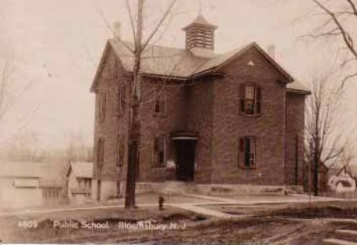

**DATES TO REMEMBER**

**December 26**

Christmas Tree Pickup Begins

**January 18**

Christmas Tree Pickup Ends

**Date to Be Determined**

2021 Free Rabies Clinic

**VOLUNTEERS NEEDED** Part of what makes Bloomsbury unique, is our volunteers!

Meetings are once a month.

Please contact the Borough Clerk at 908-479-4200.

**BLOOMSBURY HOSE CO. # 1**

*Members needed! Call Chief Pflugfelder 908-442-0031*

Page 1 of 6

**COVID-19 Information**

**COVID-19 Vaccination**

In anticipation of the approval of a safe and effective COVID-19 vaccine, the Department of Health is working with many other state, federal, and local agencies to plan for the fast and equitable distribution of a vaccine to all New Jersey communities. It is the goal of the Department of Health to make safe and effective COVID-19 vaccination available to all who live, work, and/or are educated in New Jersey.



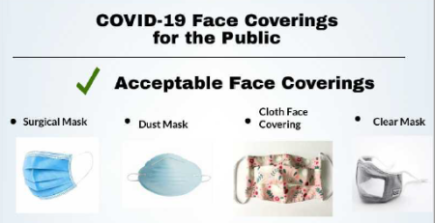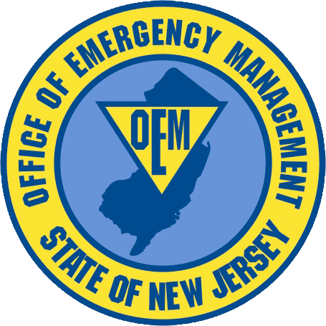

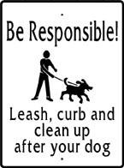

**FRIENDLY REMINDER**

From the Office of Emergency Management. Please check your smoke detectors! Landlords, please be sure to supply them to your tenants!

**Snow Removal**

As a reminder to Borough Residents, the Borough Code prohibits any person from placing snow or ice on the public streets. Any resident doing this is subject to a maximum penalty upon conviction of a fine not exceeding $2,000.00.

_____________________ **CLEAN UP AFTER YOUR PETS!**

**Borough Ordinance #108-06**

HELP KEEP BLOOMSBURY **BEAUTIFUL!**

Picking up after your pet is not only common courtesy

**It’s the LAW!**

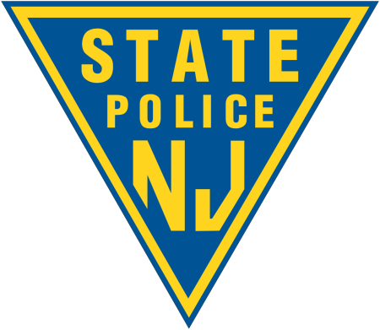

Winter emergency information alerts will be sent by email, when time allows, to everyone who has signed up.

**Snow Parking Reminder**

All motor vehicles must be removed from the streets in the Borough when more than 2" of frozen

precipitation falls and must remain off the street until 12 hours after the cessation of frozen precipitation

events.

**BOROUGH PARK RULES**

* Park CLOSED from Dusk to Dawn.
* No Alcoholic Beverages.
* No Glass Containers.
* No Dumping.
* No ATV vehicles.
* Pets must be leashed at all times.
* Owners must clean up pet waste.

Anyone observing any violation should contact the State Police by dialing 908-730-7042 immediately.

**Violators will be prosecuted.**

**REDUCE, REUSE, RECYCLE!!!**

[**RECYCLE COACH**](http://www.co.hunterdon.nj.us/recycling/RecycleCoach.html) **Helpful Recycling Information  
in Your Municipality**

**Available for Bloomsbury!**

**Download your FREE APP  
which connects Hunterdon County Residents  
with Recycling Information**

**[](https://www.co.hunterdon.nj.us/recycling/RecycleCoach.html)**

Residents and visitors needing additional off-street parking during inclement weather, can park at the

Borough Park located at 100 Church Street, or at 98 North Street in the lot located at the corner of Gardner

Street and North Street.

Parking is at your own risk and please be sure to remove vehicles from the lots as soon as the streets are

completely clear. If you have any questions or concerns, please call Borough Hall at 908-479-4200.

Beginning November 15th and ending March 31st, there shall be **NO PARKING** on the south side of

**Brunswick Avenue** from its intersection with Church Street (Route 579) to its intersection with Route 173

during and following any period of frozen precipitation (e.g. snow, sleet, etc.) for so long as the roadway

is not entirely free of accumulations of frozen precipitation.

**Winter Snow Removal**

After Council’s review of the Borough’s snow removal practices, a decision was made that non-essential alleys that are difficult to navigate either by reason of their configuration or man-made obstructions will be cleared when manpower and conditions permit.

As a result, if plow drivers of the Borough’s DPW determine in their sole discretion that accessing or attempting to plow any of these alleyways is dangerous and could result in either damage to a borough vehicle or to an adjoining residence, snow will not be removed from those alleys until conditions permit safe passage for DPW vehicles.

This is in accordance with New Jersey Statutory Regulations which only require removal of snow and/or ice from main thoroughfares within the Borough.

The Bloomsbury Hose Company requests your assistance and ask that you clear snow from around any hydrant adjacent to your property.

Page 3 of 6

**All-terrain vehicle (ATV) or Dirt bikes**

You do not need a permit or license to operate an all-terrain vehicle (ATV) in New Jersey. However, the vehicle must be [registered](http://www.nj.gov/mvc/Vehicle/Snowmobiles.htm) and you must observe the following regulations:

* Operator must be at least 14 years old.
* Always carry proof of liability insurance and current registration.
* Use the ATV or Dirt Bike for off-road use only. They are not permitted on public street or roads.
* If you are under 18 years old, you must enroll in the [ATV Safety Institute course](http://www.atvsafety.org/) to operate an ATV, if you are operating a dirt bike you must enroll in the safety course provided by [dirtbikeschool.com](http://dirtbikeschool.com/) to obtain a safety certificate*. For information on fees and duration of the course, please check their website or call (800) 887-2887.
* Anyone under the age of 16 is prohibited from operating an ATV or Dirt Bike with an engine capacity greater than 90 cubic centimeters during training or while on public lands or waters or to cross a public roadway.
* Individuals cannot sell more powerful ATVs or Dirt Bikes to anyone under 16 years of age.
* ATV/Dirt bike use is prohibited in all New Jersey State Parks and Forests – no exceptions.

*If you are under 18 years old and only operate an ATV or Dirt Bikes at licensed special events, you are exempt from the safety education course. You are also exempt if the ATV or Dirt Bike is used on public lands or waters or across a public highway as an incident to or in the actual performance of the operations of a farm that is adjacent to the public land and or water or public highway upon which the vehicle is being operated.

This information was provided by the State of New Jersey Motor Vehicle Commission. Additional information can be found at the following sites:

<http://www.atvsafety.org/>

http://[www.dirtbikeschool.org/](http://www.dirtbikeschool.org/)

https:[//www.state.nj.us/mvc/pdf/license/snowman.pdf](http://www.state.nj.us/mvc/pdf/license/snowman.pdf)

**Tips for Winter**

Federal Guidelines dictate that the face of your mailbox should be placed 6”- 8” behind the curb. It should be firmly secured to the mailbox post. Lag bolts and screws work better than nails. There are many types of posts to choose from, depending on which one you choose, will determine the life span. If your mailbox and post are a number of years old, please replace it correctly. Remember using good quality material will last the longest and good quality doesn’t necessarily mean the most expensive. Removing the snow from around your mailbox will help prevent damage to your post.

When clearing snow from your driveway, please keep in mind that Bloomsbury Borough’s Ordinance prohibits pushing / blowing snow into the roadway. Please let your snow removal contractor know this as well and it will help maintain safe travel for all. On garbage / recycling day please keep your cans out of the roadway if possible. Please give plenty of room between you and the snow / salt trucks drivers, don’t follow too close (stay back at least 200 feet) and give the drivers plenty of room to do their job. And please remember… no parking on the roads on snow days and keep vehicles off the street for at least 12 hours after the cessation of precipitation.

All Dogs and Cats **MUST** be licensed by **January 31, 2021** to avoid late fees.

Residents Can Not Obtain Licenses in Person **(Drop-off ONLY!)**

Completed applications can be dropped off or mailed to Borough Hall at 91 Brunswick Avenue, Bloomsbury, NJ 08804.

Additional applications can be obtained online at [**www.bloomsburynewjersey.com**](http://www.bloomsburynewjersey.com/)

**Fee Schedule (including late fees)**

All applications must be accompanied by a copy of a valid Rabies Certification showing proof of rabies vaccination with an expiration date after October 31st of the licensing year.

|  |  |  |  |  |
| --- | --- | --- | --- | --- |
|  | Month | Licensing Fee Per Spayed or Neutered Cat/Dog | Licensing Fee Per Non-Spayed or Non- Neutered Cat/Dog |  |
|  | January | $8.00 | $11.00 |  |
|  | February | $13.00 | $16.00 |  |
|  | March | $18.00 | $21.00 |  |
|  | April | $23.00 | $26.00 |  |
|  | May | $28.00 | $31.00 |  |
|  | June | $33.00 | $36.00 |  |
|  | July | $38.00 | $41.00 |  |
|  | August | $43.00 | $46.00 |  |
|  | September | $48.00 | $51.00 |  |
|  | October | $53.00 | $56.00 |  |
|  | November | $58.00 | $61.00 |  |
|  | December | $63.00 | $66.00 |  |
|  |  |  |  |  |

Please detach the lower portion of this sheet and return with your check made payable to: Borough of Bloomsbury for the appropriate fees, self-addressed stamped envelope and proof of rabies vaccination.

An additional fine of $100 per Dog and $50.00 per Cat will be assessed for unlicensed animals found by the Code Enforcement Officer or the Animal Census Coordinator.

Court fees may also apply.

Do not mail cash.

Licenses **will not** be mailed back to you unless a **self-addressed stamped envelope** is included!!

----------------------------------------------------------------------------------------------------------------------------- ----------------------------

**Owner's Name**: Date:

**Address**: Phone:

**Email Address:**

**Circle One**: Dog Cat **SEX**: M F Breed: Age:

**Color/Markings**: Name:

**Circle One: Hair**: S M L **Spayed/Neutered:** Yes No **Rabies Vaccination Expires**:

**FREE RABIES CLINIC – Date to Be Determined - BLOOMSBURY FIREHOUSE**

# Winter 2020 Letter from Mayor Papics

*December 2020*

*Happy Holidays Bloomsbury,*

*I hope this finds you all in good health and spirits for the craziest year ending.*

*2020 cannot be gone… soon enough. It has been a very trying year for all of us and we have graciously endured, what seems to be a never-ending headache. I’m sure like most, plans and activities changed multiple times during the year. We all are anticipating a great new year, with no surprises and many accomplishments.*

*The NO TRUCK picture signs, according to some residents, are working. We will still have that stray truck roar through, smh. We did have a rough start with them…wait for it……a truck ran over the picture sign on the corner by Casola’s Pizza. You can’t make this stuff up.*

*With the plans handed in, the Main St. project should commence sometime in the spring. We will have new sidewalk ramps, some sidewalk repair, drains, curbs, and blacktop from Gardner to Wilson.*

*I’m also excited to announce that the state did approve the grant for Willow Ave, near the old water company. I’ll update you next newsletter.*

*Our big pine tree at the Main St. point looks amazing lit up this year. Thank you to all those volunteers that helped with the logistics. The BCC holiday flags look great hanging around town. Without you and many others in and out of town who care, we would not be the Borough of Bloomsbury many love to call home. Volunteers are always welcome.*

*So…Enjoy your holidays, shovel your sidewalk. Have a safe winter.*

*Mayor Papics*